There are two ways through which we can change the folder where artifact is saved.

1. Go to→component →process→configuration of process → basic settings→change default working directory

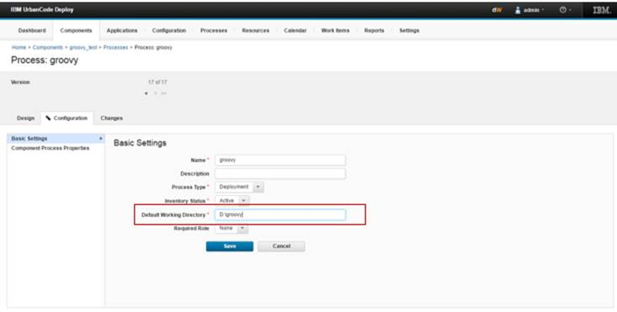

1. Go to→component →process→configuration of process →design

In download artifact step add following configuration –

Provide the directory path in working directory field.

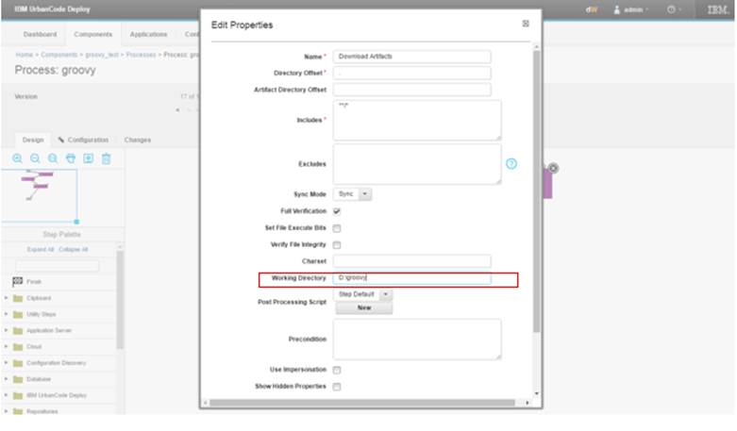

The artifact is getting saved to the given path.

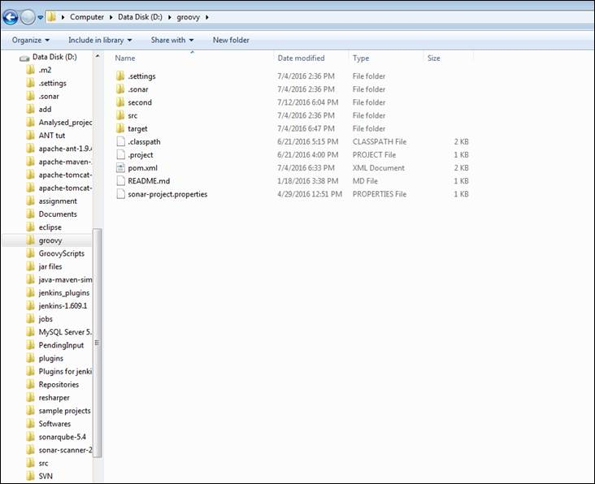

1. Create a property and use that property at process configuration

Go to 🡪 settings 🡪system settings 🡪 properties🡪 add property 🡪 give path of directory where you want to save it and name of property 🡪 save

Go to→component →process→configuration of process → basic settings→change default working directory 🡪 provide directory as ${p:propertyname}\$(componentname}



1. Create a template

While creating a template provide directory here

Invoke this template while creating component